Gorman Law

10053193

CPSC 501 Assignment 4 Regression Testing

For regression testing, I imported the convolved wav file into Audacity and compared their graphs.

Dry Recording

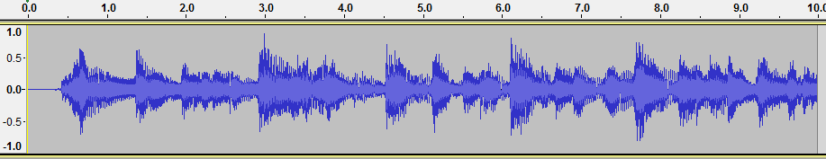

Baseline Convolution

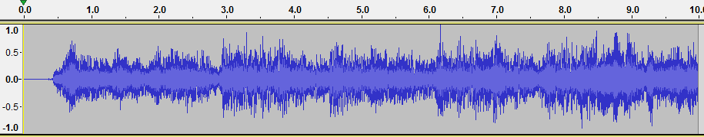

FFT Convolution

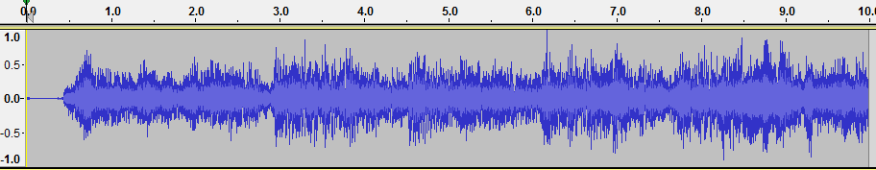

FFT Convolution (after tuning one)

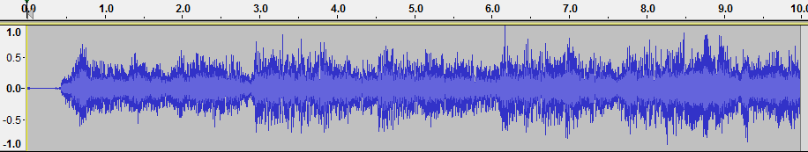

FFT Convolution (after tuning two)

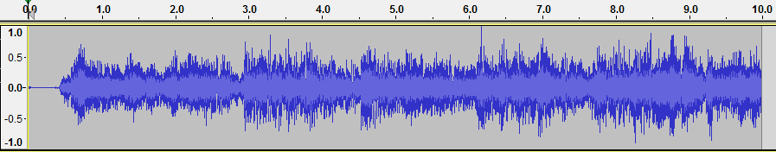

FFT Convolution (after tuning three)

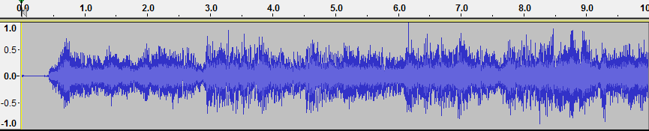

FFT Convolution (after tuning four)

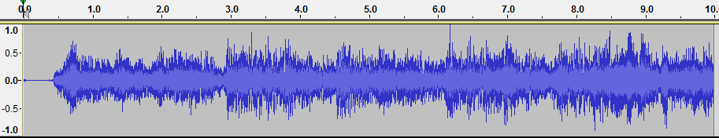

FFT Convolution (after tuning five)

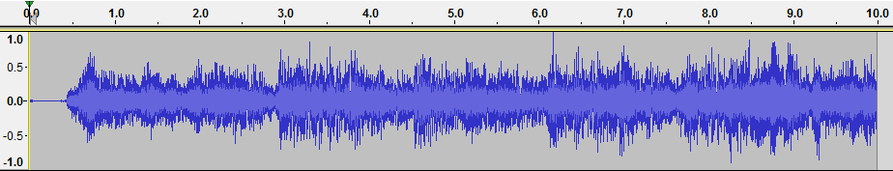

FFT Convolution (after tuning six)

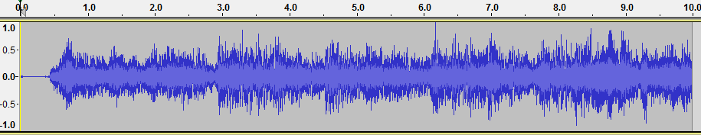

As we can see from the graphs, before and after tuning, the sound remains exactly the same, which means the code tuning did not screw anything up. A success!